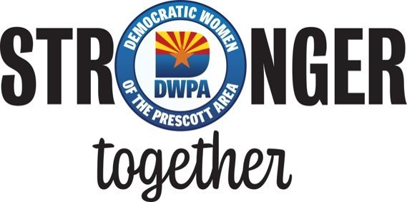
November 21, 2022
Laurin Custis
Yavapai County Elections Director
1015 Fair Street, Room 228 Prescott, AZ 86305
Dear Ms. Custis:
On behalf of the Democratic Women of the Prescott Area (DWPA), we would like to congratulate you on your recent appointment to the office of Yavapai County Elections Director by the Yavapai County Board of Supervisors.
While your predecessor’s withdrawal was predicated by the harassment and threats from those who were deceived by the lies regarding the integrity of our elections in Arizona, it is the sincere hope of our organization and its members that such harassing communications cease and that you are able to fulfill the duties of your office without such distressing distractions.
Free and fair elections are the basis of our democracy. Former Recorder Leslie Hoffman and former Elections Director Lynn Constabile conducted efficient and fair elections for many years. As you have worked in the same office with both of these officials since 2015, we have the greatest confidence that you will continue this commitment to conducting the elections process in our county with the same devotion to efficiency and professionalism.
Best wishes for your success, both personally and professionally, in this new position.
DWPA Chair
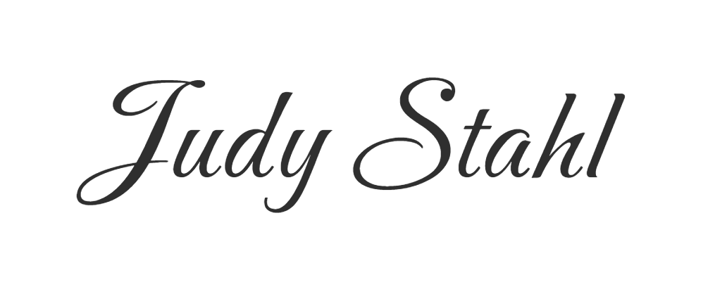
Kathleen Sauer
DWPA Vice-Chair
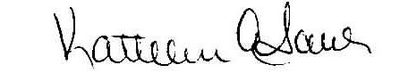

Note: November 21, 2022 Laurin Custis responded:
Thank you, Judy and Kathleen!
I look forward to working with you both.
Best, Laurin

